**Broadband Availability Analysis between IPV4 and IPV6**

**1. Introduction**

Version 4 of the Internet Protocol (IPv4) has been in wide use for the past 25 years, but it has outlasted its effective lifetime and is straining to keep up with the demands of today's Internet. IPv6 is a natural evolution from IPv4 and attempts to address many of the older protocol's shortcomings. IPv6 is designed to keep up with the rapid growth of the Internet [1]. However, IPv6 is frequently questioned for its reliability due to its new thriving. The IPv4 network has now evolved into a mature, steady stage characterized by a relatively slow growth with a stable [network structure](https://www.sciencedirect.com/topics/computer-science/network-structures); whereas the IPv6 network, after a slow startup process, has just taken off to a full speed growth [2].

In this paper, we compare the estimated availability between IPv4 and IPv6. Basically we explore the availability of IPv4 and IPv6 from four aspects of the dataset:

(1) Availability synchronization

(2) Availability among carriers

(3) Availability among tiers

(4) Availability over time

to evaluate the current reliability of IPv6 in the United States on the basis of the counterpart of IPv4.

**2. Availability of IPv4 and IPv6**

**2.1 Dataset**

For exploration of availability, we use the broadband dataset of IPv4 downloading, IPv4 uploading, IPv6 downloading and IPv6 uploading respectively during the first half year of 2018. We assume the data size within the time range could already be a good representative of the overall availability statistics of IPv4 and IPv6. Except for that, we apply another unit profile dataset to merge the information of testing nodes, including technology, which means the technology used for the connection of this node; carrier, which the internet service provider of this node as well as the download and upload tiers.

**2.2 Metrics**

We apply availability of the network as a quantitative indicator of the network reliability. Availability is defined as the fraction of time the service is in functioning condition [3].

More specifically, if the network works all day and only down from 2pm to 3pm, the availability is calculated as 23/24. In this paper, we will use hour as the unit to calculate availability.

**2.3 Data Cleaning**

The datasets we use for availability exploration are the raw dataset directly downloaded from FCC official website. The dataset is considerably messy and includes the nodes that have to be eliminated. For IPv6 availability, some of the nodes have not received IPv6 service yet. Only those nodes with a descent time range of IPv6 available will be considered. To be more specific for this dataset, the overall time range is 6 months, so we set the threshold to 120 days, which means we eliminate the nodes that have less than 120 days’ records of IPv6 service available. Finally, we have 4475 nodes left for IPv4 download dataset, 862 nodes left for IPv6 download dataset, 4471 nodes left for IPv4 upload dataset and 860 nodes left for IPv6 upload dataset. We only include the nodes that is qualified for all four situations: IPv4 download, IPv6 download, IPv4 upload and IPv6 upload. The final number of nodes left for analysis is 857.

After that, since we decide to use hour as the unit for availability, there is a lot of missing data to fill. According to Bischof, Zachary, Fabian Bustamante and Nick Feamster, the availability of IPv4 under normal situations is over 99 percent [4], thus filling in the missing data with 1 (1 means available) makes sense.

In all, the final dataset consists of 857 nodes and their availability between 2018-01-01 and 2018-06-30 with hour as unit.

**2.4 Experiment Results**

**2.4.1 IPv4 and IPv6 Availability Synchronization**

First of all, the IPv4 and IPv6 unavailability synchronization is worth exploring. According to Berger and Arthur in 2013 [5], the corresponding IPv4 and IPv6 addresses are assigned to the same machine, and thus being at the same location, which implies that IPv6 uses the same technology and line as that of IPv4 for the same node. Thus theoretically, IPv4 and IPv6 availability synchronization is mandatory. However, we found something violating this law.

According to our research, only for 81.7% of the time the phenomenon of availability synchronization exists. The situation that only IPv4 is available accounts for about 18% of the whole time range and that only IPv6 available accounts for 0.3%. We use hour as the unit for our experiment, thus 0.3% is totally within acceptance. According to symmetry, the two statistics should be about equivalent but the 18% is too large compared to 0.3%. Thus we can come to the conclusion that IPv6 is less stable than IPv4 because there is much higher probability that only IPv4 is available than that only IPv6 is available. What should be noticed is that we have eliminated the nodes that do not receive IPv6 service. As for why the results violate the synchronization, it is worth further exploring.

**2.4.2 Availability Among Carriers**

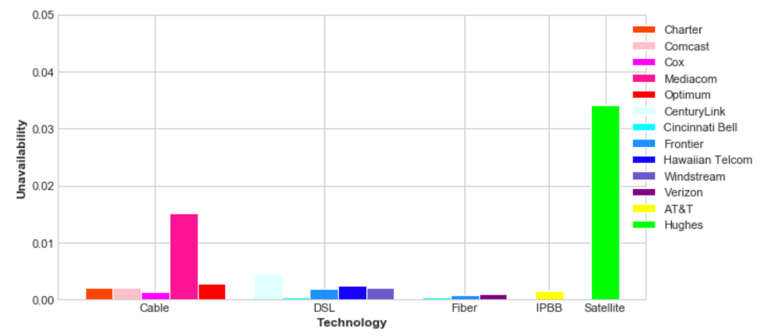

Figure 1. IPv4 Download Among Carriers

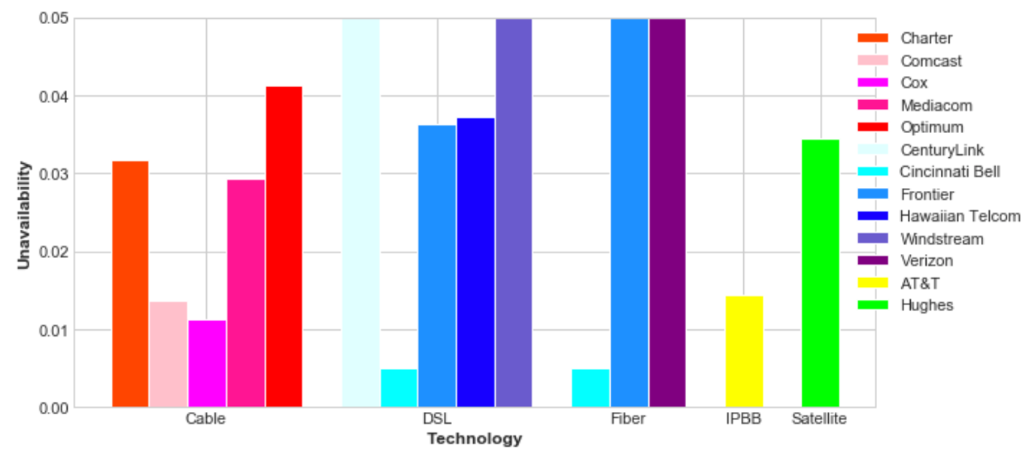

Figure 2. IPv6 Download Among Carriers

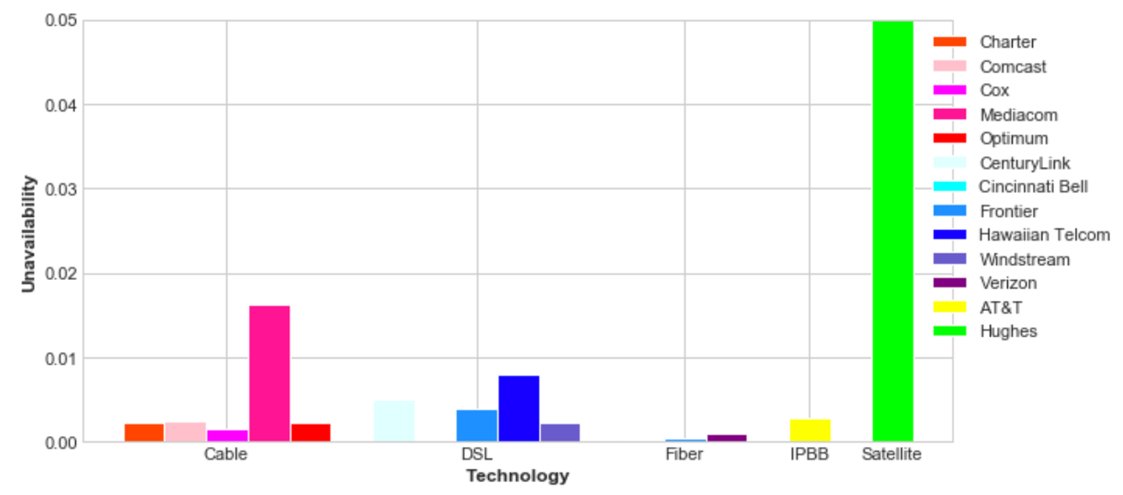

Figure 3. IPv4 Upload Among Carriers

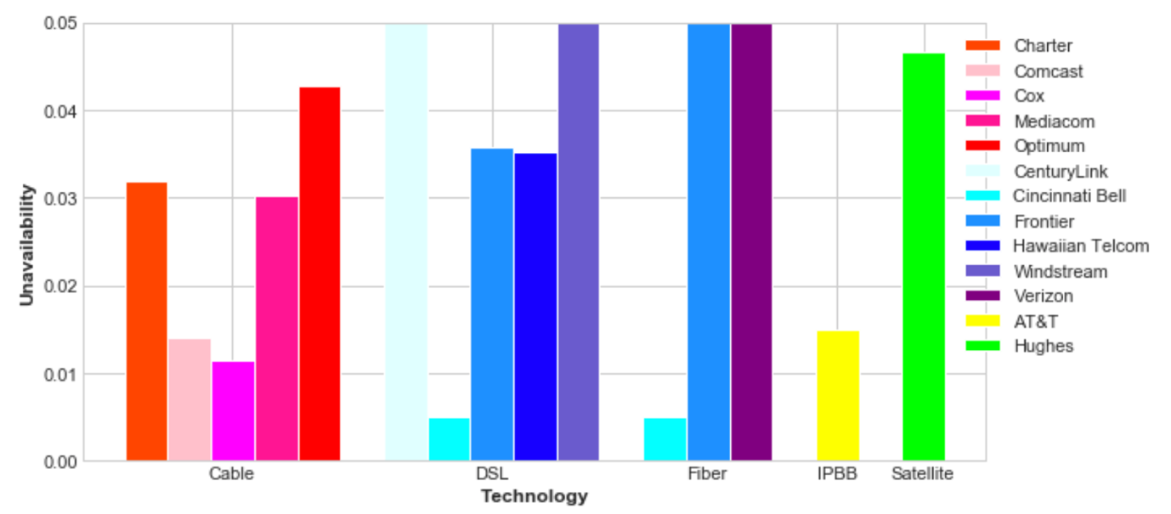

Figure 4. IPv6 Upload Among Carriers

The figures above are calculated by the technology and carrier group average availability. We set a minimal availability threshold to 95%, which implies that the bars reaching the top could indicate availability far lower than 95%. As the figures shown, we can come to the following conclusions:

(1) Compared with download statistics, upload statistics are in almost exactly the same pattern.

(2) Among technologies, satellite performs the worst in term of availability for IPv4, and Mediacom performs the worst among cable technology for IPv4. Except for these two, the availability of IPv4 provided by all the other technologies and carriers are over 99.5%.

(3) Compared with the availability of IPv4, IPv6 performs much worse.

(4) Cincinnati Bell is the only carrier who could provide IPv6 service with more than 99% availability.

(5) Though Mediacom and Hughes performs worse in terms of IPv4, it is tricky that they perform the best in terms of the availability increase from IPv4 to IPv6. Hughes (satellite) performs equivalently even better in IPv6 service compared to IPv4 service.

It is most significant that IPv6 indeed has lower availability than IPv4 generally.

**2.4.3 Availability Among Tiers**

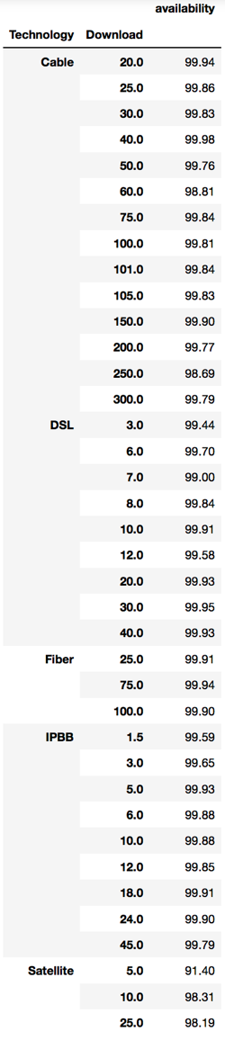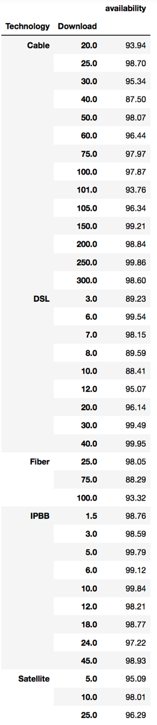

Figure 5. Availability Among Tiers between IPv4 Download and IPv6 Download

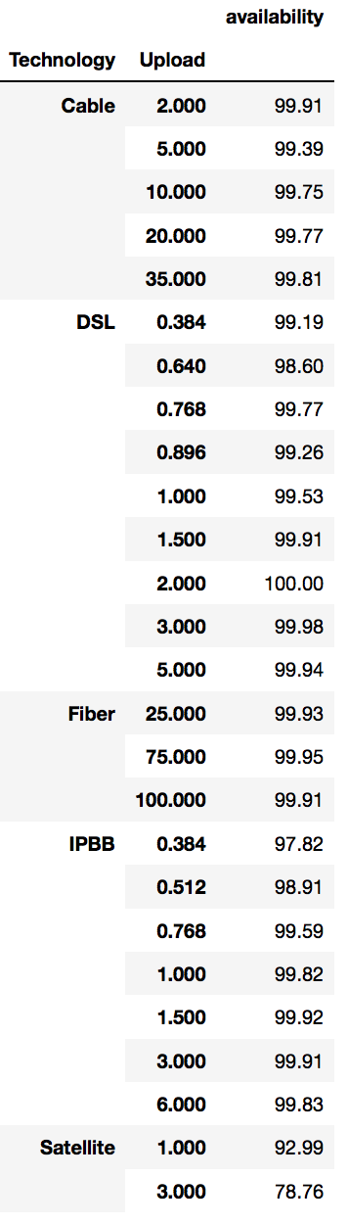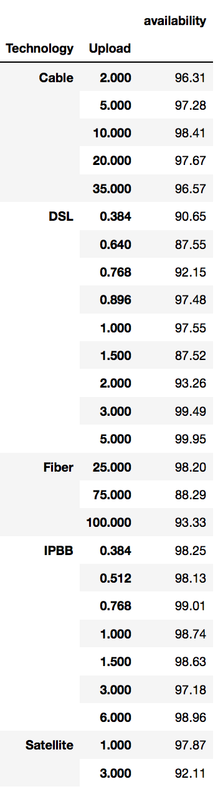

Figure 6. Availability Among Tiers between IPv4 Upload and IPv6 Upload

The figures above are calculated by ties group average availability. There is no strong proof that ties have a large influence on the availability of IPv4 and IPv6 service, but we found trivial evidence that small tiers may cause lower availability for both. Further proof needs to be done on this guess.

In terms of the comparison between IPv4 and IPv6, IPv4 availability is more than 99 percent for most ties except for the ties of satellite technology. While for IPv6, only a few ties own availability over 99 percent. So from the perspective of ties, IPv4 is better than IPv6 on availability.

**2.4.4 Availability Over Time**

We use the availability of cable service provided by Charter and Comcast as an example. The figures of other technologies and carriers are similar to these two. Figure 7 and Figure 8 are the availability of cable service provided by Charter and Comcast respectively. In this sector, day is the unit we use for plotting.

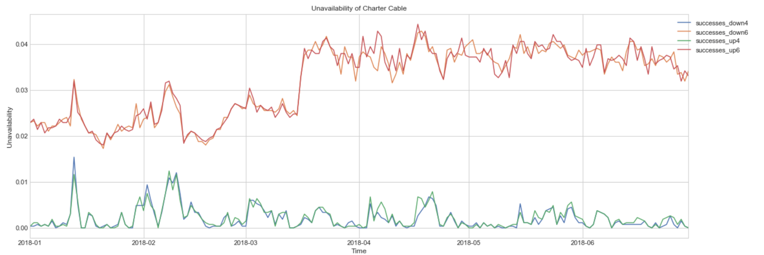

Figure 7. Availability of Cable Service Provided by Charter Over Time

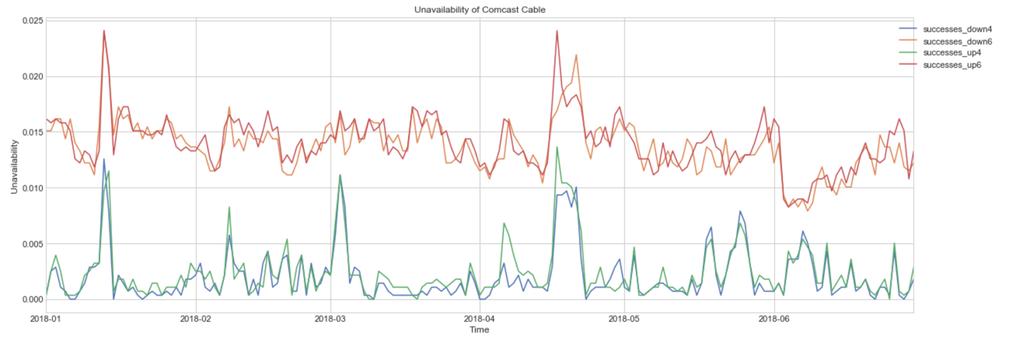

Figure 8. Availability of Cable Service Provided by Comcast Over Time

From the figures above, we could draw the conclusion that the availability curves of download and upload overlap almost perfectly over time both for IPv4 and IPv6 service. However, IPv4 service performs obviously better than IPv6 service. Thus from the perspective of availability over time, we come to the same conclusion that IPv6 indeed has lower availability than IPv4 generally.

**3. Conclusion**

In this paper, we intend to compare the availability between IPv4 and IPv6 from four aspects of the FCC broadband dataset: availability synchronization, availability among carriers, availability among tiers and availability over time.

For availability synchronization, we found the time range of the phenomenon that only IPv4 available is much longer than that only IPv6 is available. When it comes to availability among carriers, we found the IPv4 availability is higher than IPv6 availability for most carriers and technologies except for satellite. For availability among tiers, we found that IPv4 availability is more than 99 percent for most ties while IPv6 owns only a few ties with availability over 99 percent. At last but not least, the timeline curves indicate the same results. In all, we come to the conclusion that the availability of IPv4 service is significantly better than that of IPv6.

We hope this paper will provide readers with the initial ideas and conclusions about the comparison between IPv4 and IPv6 and contribute the rapid development of advancement of IPv6 service.

**4. Future Work**

Though the conclusion is drawn, the reason behind the conclusion is worth further exploring. Also, the conclusion seems applicable for most of the technologies except for satellite. It will be interesting to explore why satellite availability is so special compared with others. What’s more, the exploration of lasting time of IPv4 and IPv6 outrages will be meaningful to further understand the difference between IPv4 and IPv6.

**5. Acknowledgements**

We would like to thank Professor Henning Schulzrinne at Columbia University for his support and instruction on this project.

**References:**

[1] Durand, Alain. "Deploying ipv6." IEEE Internet Computing 5.1 (2001): 79-81.

[2] Zhang, Guoqiang, Bruno Quoitin, and Shi Zhou. "Phase changes in the evolution of the IPv4 and IPv6 AS-Level Internet topologies." Computer Communications 34.5 (2011): 649-657.

[3] Lehr, William, et al. "Assessing broadband reliability: Measurement and policy challenges." Research Conference on Communication, Information and Internet Policy (TPRC). 2011.

[4] Bischof, Zachary, Fabian Bustamante, and Nick Feamster. "Characterizing and Improving the Reliability of Broadband Internet Access." TPRC, 2018.

[5] Berger, Arthur, et al. "Internet Nameserver IPv4 and IPv6 Address Relationships." Proceedings of the 2013 conference on Internet measurement conference. ACM, 2013.